# Title:

asdfasdf

# Scenario:

asdf

# Screener:

Leader/Manager

# Participants number:

3

# Schedule date:

02/28/2022

# Image:

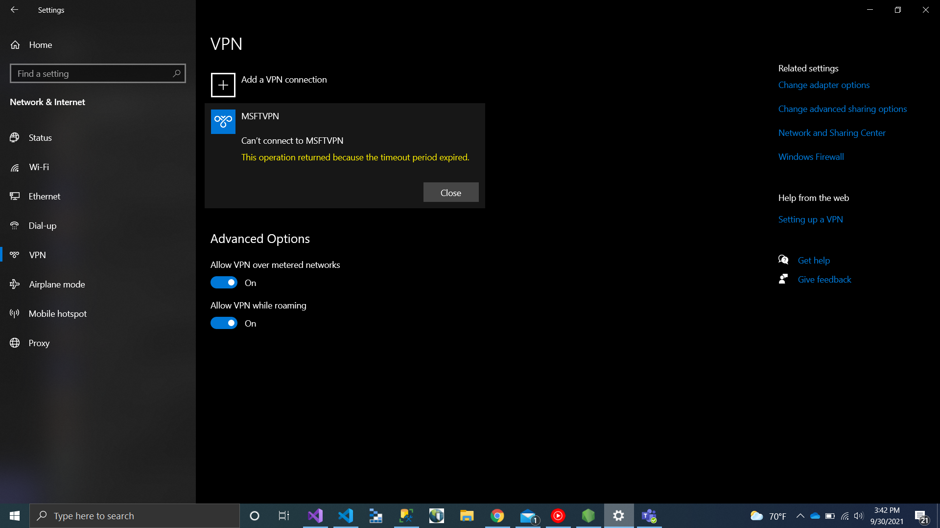  
Screenshot (7).png

# Instruction text:

asdfasdf

# Participants:

asdf